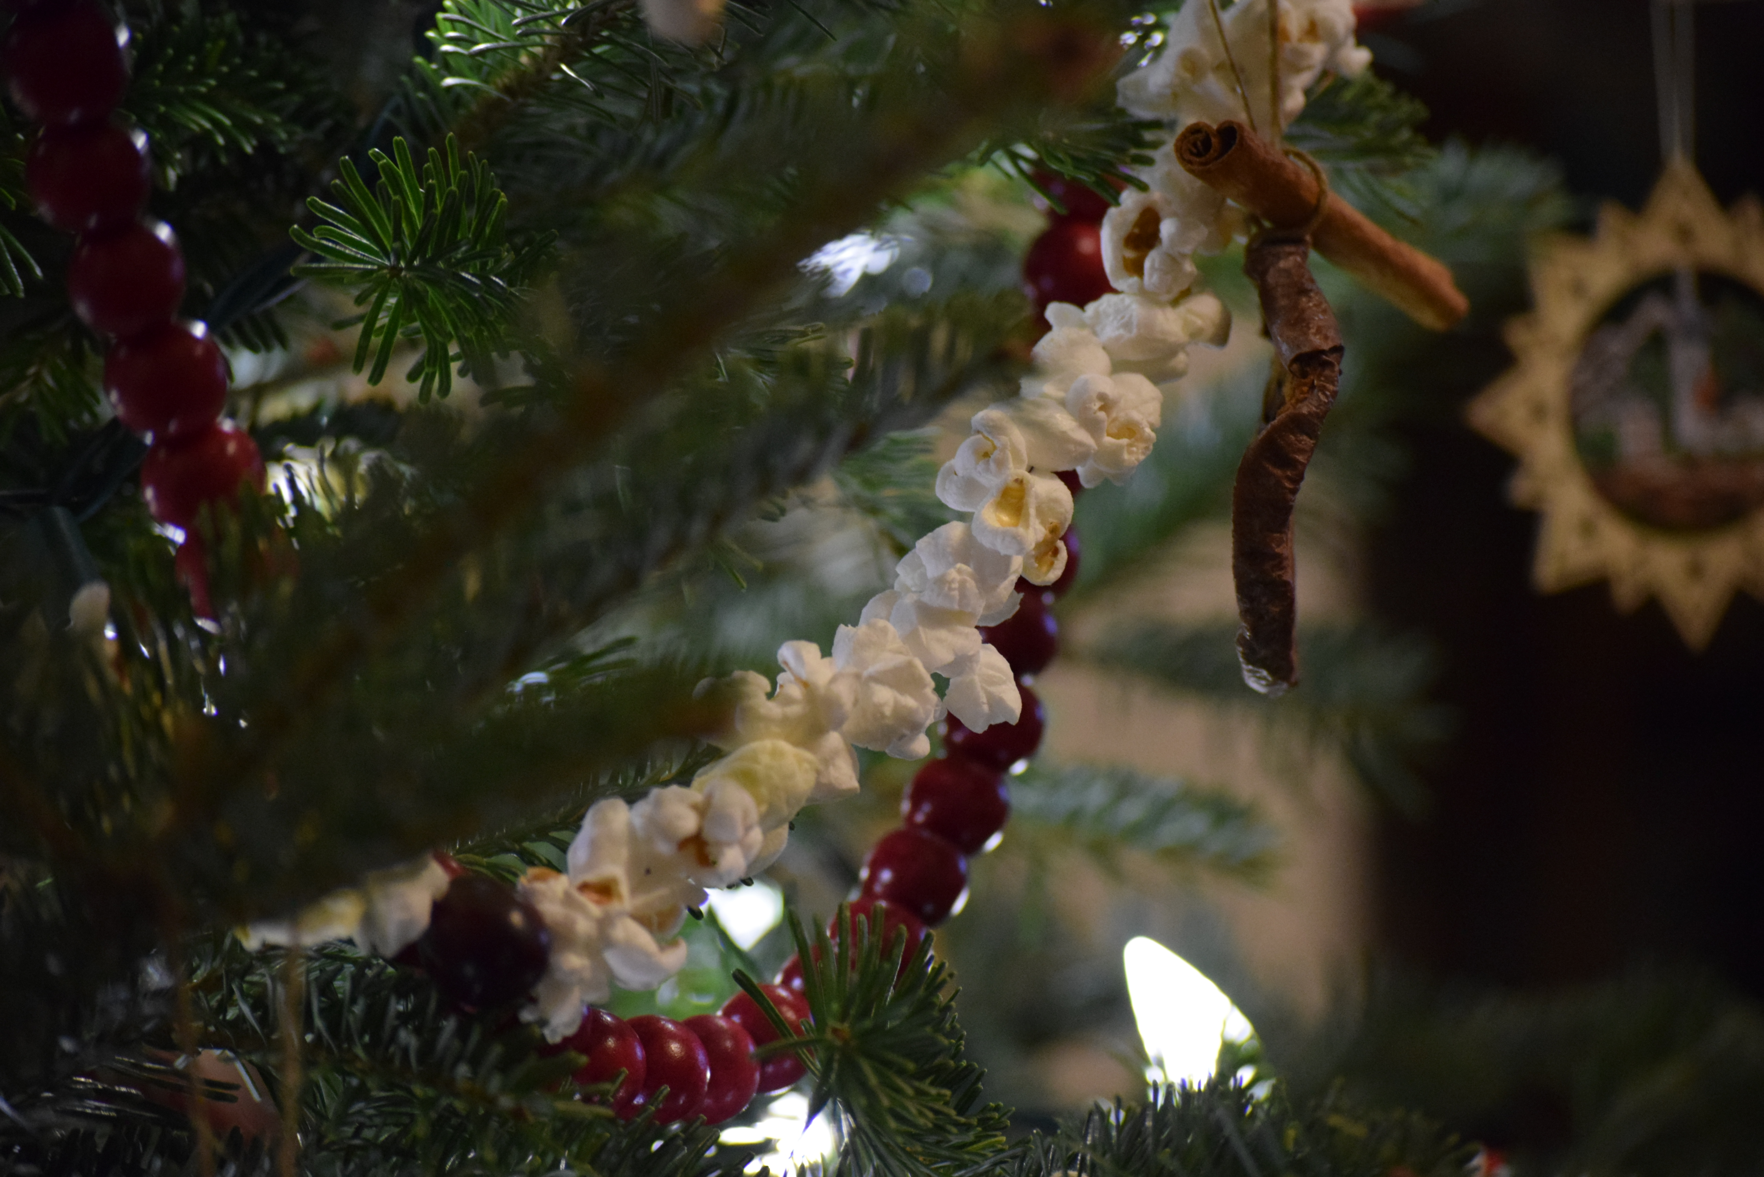
JOIN US FOR A
-------------------------------------

free community event

Sponsored by TCC and Graceful Harvest of Upper Adams Community
-------------------------------------
Saturday, December 6
9am to 11am
Heidlersburg Fire Hall
2720 HEIDLERSBURG ROAD
Gettysburg, Pa 17325
We are in need of donors to give toward the Christmas Trees and to collect toys and coats.  This is what you can do to help out with the cost. Consider donating funds to help cover the cost of a Christmas tree (Each tree costs $65.00) or start collecting coats and toys. (Contact Temple Court Community for Pick up at 717-798-2470)  This is a great way to serve in the Upper Adams Community. Join us in a day of spreading God’s Love to others.  Scan the QR code below to give financially toward this event. | Free Food from Graceful Harvest Ministry  Free Gently used Coats for children and adults and gently used toys for children.  Free Live Christmas Trees  Free Haircuts and Family Photos  Free crafts to make and many other family-oriented booths

